Using jQuery that demonstrates:
- Selectors
- Events
- Effects (hide/show)
- Simple Form Validation
==============================================================================
COMMAND:
<!DOCTYPE html>
<html>
<head>
<title>jQuery Demo</title>

<!-- jQuery CDN -->
<script src="https://code.jquery.com/jquery-3.6.0.min.js"></script>

<style>
body {
font-family: Arial;
margin: 40px;
}
.error {
color: red;
font-size: 14px;
}
#box {
width: 200px;
height: 100px;
background-color: lightblue;
text-align: center;
line-height: 100px;
margin-top: 20px;
}
</style>
</head>

<body>
<h2>jQuery Demonstration</h2>
<!-- Form -->
<form id="myForm">
Name: <input type="text" id="name"><br><br>
Email: <input type="text" id="email"><br><br>
<span class="error"></span><br>
<button type="submit">Submit</button>
</form>
<br>
<!-- Hide/Show Buttons -->
<button id="hideBtn">Hide Box</button>
<button id="showBtn">Show Box</button>
<div id="box">Hello!</div>
<script>
$(document).ready(function(){

// SELECTOR Example
$("#hideBtn").click(function(){
$("#box").hide(); // Hide effect
});

$("#showBtn").click(function(){
$("#box").show(); // Show effect
});

// EVENT + FORM VALIDATION
$("#myForm").submit(function(event){

var name = $("#name").val();
var email = $("#email").val();

// Clear previous error
$(".error").text("");

if(name === "" || email === ""){
$(".error").text("All fields are required!");
event.preventDefault(); // Stop form submission
}
else if(!email.includes("@")){
$(".error").text("Enter a valid email address!");
event.preventDefault();
}
else{
alert("Form submitted successfully!");
}
});

});
</script>
</body>
</html>

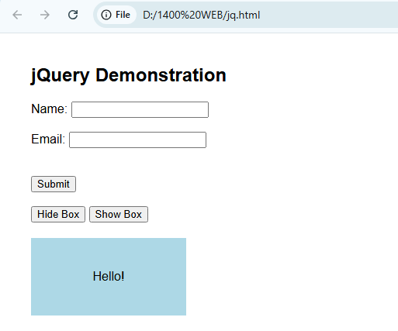
OUTPUT:

